No. | Answer
a KHCO₃(s) + H⁺(aq) → K⁺(aq) + H₂O(l) + CO₂(g)
b Fe₂O₃(s) + 6H⁺(aq) → 2Fe³⁺(aq) + 3H₂O(l)
c OH–(aq) + H⁺(aq) → H₂O(l)
 | 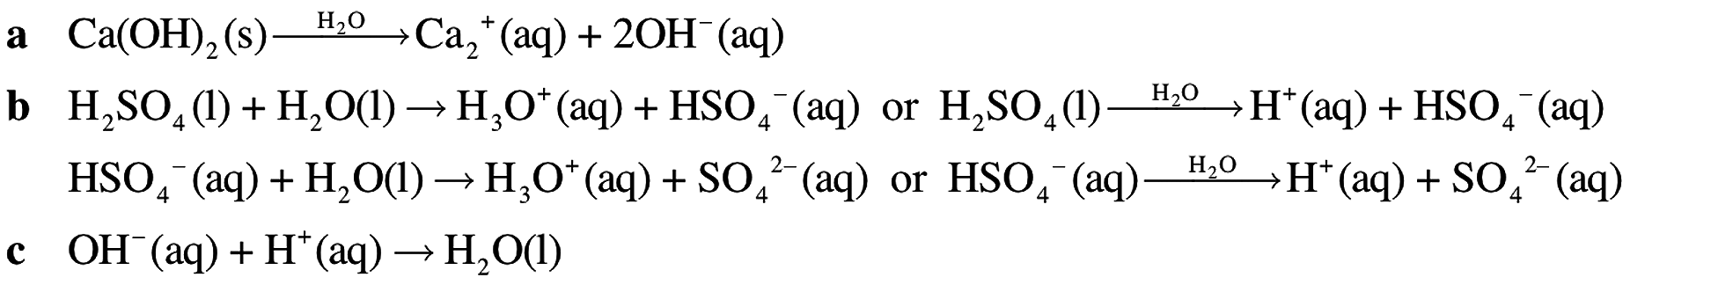
a S^{2–} and O^{2–}
b H₂SO₄ and H₃PO₄
a HCO₃–/ CO₃^{2–} and H₃O⁺/H₂O
b HS–/ S^{2–} and H₂O/OH–
c HCl/Cl– and NH₄⁺/NH₃a
a HSO₄–(aq) + OH–(aq) → SO₄^{2–}(aq) + H₂O(l)
b HSO₄–(aq) + H₃O⁺(aq) → H₂SO₄(aq) + H₂O(l)
 | Different acid strengths (e.g. one strong, one weak) or different acid types (e.g. one monoprotic, one diprotic)
a Methanoic acid is a weak acid that only partially ionises in water, producing few ions and so having low conductivity. Hydrochloric acid is a strong acid that ionises completely in water, producing many ions and so having high conductivity.
b Only the O–H bond has sufficient polarity to make the hydrogen atom acidic. The three C–H bonds are only slightly polar, so these hydrogen atoms are not acidic.
The solutions listed in order of decreasing pH are:
NaOH is a strong base, ∴ high pH
NH₃ is a weak base, ∴ pH > 7 but not too high
H₂O has pH = 7
CH₃COOH is a weak acid, ∴ pH < 7
HNO₃ is a strong acid, ∴ low pH
H₂SO₄ is a strong, diprotic acid, ∴ pH < pH of HNO₃
 | A 10–fold dilution produces a change of one pH unit so the pH must increase by 1 unit to a value of 4.
a CO₂(g) + H₂O(l) → H₂CO₃(aq)
b SO₂(g) + 2OH–(aq) → SO₃^{2–}(aq) + H₂O(l)
c no reaction
d Al₂O₃(s) + 2OH–(aq) + 3H₂O(l) → 2Al(OH)₄–(aq)

